***Tube Roller [2.0]***

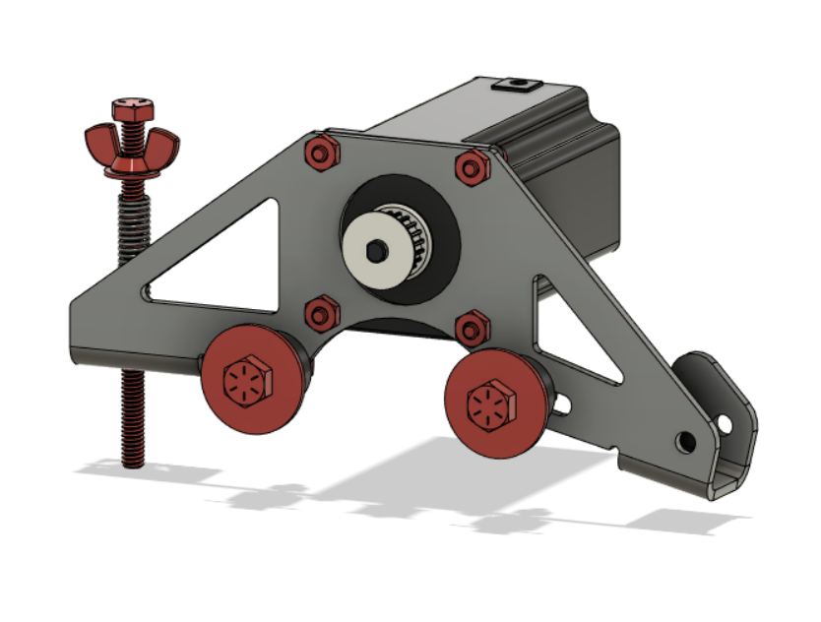

***Tube Roller Bearings [2.1]***

**Parts Needed**

**1x Tube Holder (Plasma Cut)**

**2x 5/16” x 1.25” Bolts**

**2x 5/16” Nuts**

**2x 5/16” Fender Washers**

**4x 5/16” SAE Washers**

**4x 608 Bearings**

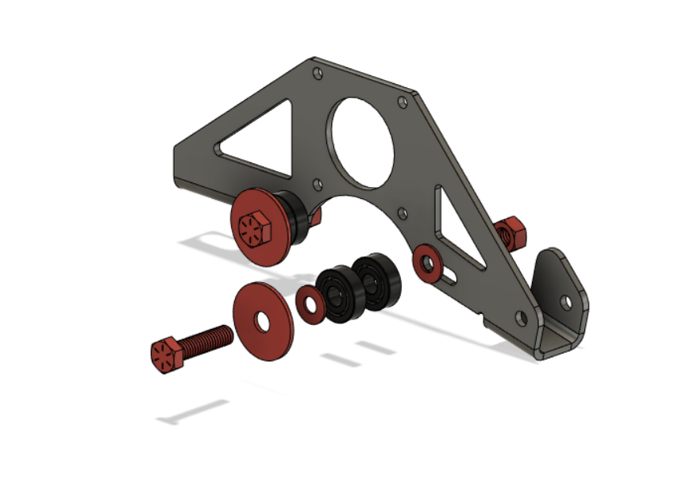

Drill out holes for 5/16” bolts as shown

***Tube Roller Motor [2.2]***

**Parts Needed**

**1x Assembly 2.1**

**4x #10-32 - 1/2” Screws**

**4x #10-32 Nuts**

**1x Nema 23 269in-oz motor**

**1x Drive Pulley**

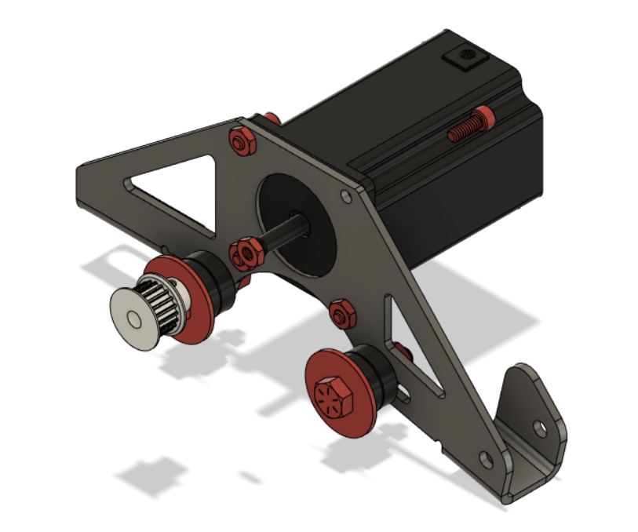

Drill out the holes to 0.020” if needed for the #10 Screws

***Belt Tensioner [2.3]***

**Parts Needed**

**1x Assembly 2.2**

**1x 1/4”x 4” Fully threaded Bolt**

**1x 1/4” Wing Nut**

**2x 1/4” Washers**

**1x Compression Spring**

